UP HATHERLEY PARISH COUNCIL
Cheltenham, Gloucestershire

Up Hatherley Parish Council: Minutes of Parish Council Meeting, held at the Village Hall, Cold Pool Lane, Up Hatherley, on Tuesday 5th January 201, at 7.30 pm.

- Members Present
Chairman Cllr. S. Fowler; P. Worsley, D. Willcox, J. Ward, A. Bamford, G. Cassell, R. Johnes, C. Mason, and R. Whyborn. Co-opted at the meeting Cllr D. Young and D. Banyard

Also in Attendance: Clerk Kathryn Oakey, Barbara Piranty CEO Gloucestershire Healthwatch and 1 parishioner.

- Apologies for absence
Cllrs. S. Bamford, and N. Holden

- Chairman’s Introduction
The Chairman welcomed all to the meeting and wished them a happy New Year. He updated members on the Greatfield Playgroup following correspondence between meetings, informing them that they proposed to match fund up to a value of £650. No further details were yet available but all present were happy with the proposal.

There was ongoing issue with the Hall roof, with a leak over one of the lights, which was under investigation.

- Cooption of New Members
The Chairman welcomed Dave Banyard, Honorary Alderman, ex-Mayor of Cheltenham, to the meeting. He is a trustee of Sandford Park Lido, and a member of Cheltenham in Bloom and would make a valuable contribution to the Parish Council. All were in agreement that he be co-opted.

The Chairman welcomed David Young, an ex-Royal Military Police officer, to the meeting. He had recently retired from a post with G4S Technology, and would make a valuable contribution to the Parish Council. All were in agreement that he be co-opted.

- Declaration of Members’ Interests
Cllr Banyard declared that he had an interest in the Cotswold Motor Group development in Grovefield Way.

- Presentation from Gloucestershire Healthwatch
The Chairman introduced Barbara Piranty CEO from Gloucestershire Healthwatch. She thanked the Chairman and informed the meeting that Healthwatch was set up as part of the Health and Social Care Act to address the issue of a patient voice. It was led by Healthwatch England and was a national body with 148 local Healthwatches across the country. It was funded from Gloucestershire County Council, and reports into their Health and Overview Scrutiny Committee.

Barbara passed around a presentation, attached as an appendix to the minutes, and a leaflet on the organisation. The body had three functions, to gather feedback, to influence behaviour by identifying trends, and advocacy.

A question was raised by a councillor, asking what happened when a complaint was not justified. Barbara responded that all complaints and contacts were taken seriously and no judgement was made even if the person was well known in the system.

A question was raised on how the service was funded, and Barbara responded that the Department of Health provide money to Communities and Local Government. That was then passed to Gloucestershire CC, who decided how much was needed to run the service.

The Chairman thanked Barbara for attending.

- Submissions from Members of the Public
Nothing had been received in advance of the meeting and the Chairman opened the meeting to the floor.
- Residents in Chargrove Lane had put in a request for “Quiet Status”, which would restrict the speed limit to 20mph. There was a questionnaire and it would be useful if the Council could support this. It was agreed that the questionnaire would be emailed to Cllr Whyborn to complete on behalf of the Parish Council.

- Minutes of the Parish Council Meeting held on 3rd November
Cllr Worsley proposed and Cllr Mason seconded and all were agreed that the minutes represented an accurate account of the meeting. The Chairman signed and initialled the pages.

- Matters Arising from Approved Minutes
The Chairman noted that there were several matters arising:
- Avenue Lodge lake was overflowing following the recent rain.
- A press notice had gone out notifying TBC’s intention of disposing of the Cold Pool Lane sports ground by means of a 25 year lease.
- Lakeside School extension was nearly finished and once completed the traffic measures and bollards would be instituted.
- Since the removal of the bus stop on Wards Road junction it had been confirmed that it was not going to be replaced. Cllr Whyborn would be speaking to Gloucestershire CC on the issue.

- Crime and Community Safety Update
Cllr Willcox reported that there had been an incident in Sefton Walk, which seemed to be an opportunistic burglary of several garden sheds. Cllr Whyborn reported that the Police did know who was involved and were gathering evidence.

- Correspondence
Correspondence received had been actioned between meetings. The Clerk noted that Gloucestershire CC Local Transport Plan was out for consultation with a closing date of 5th February. Details were on their website.

The issue of an Emergency Plan was raised, and following a debate around this, it was agreed that in the case of UHPC, a list of contacts and a cascade plan was needed rather than a detailed plan.

There had been discussions with Stagecoach since the last meeting, and it was agreed that a special meeting was needed to discuss the issue further. A date of 16th February was proposed and that would be advertised as widely as possible. (Note: This date has since been confirmed.)

Working Group Reports
- Development Control
PW’s report is shown below:

NO | ADDRESS | RESPONSE | VIEWED | DISP’D
02126 | Wisley, Sunnyfield Lane | N/O |  | online
01581 | 2 Rippledale Close | N/O criteria |  | online

Both the above applications were for home extensions and improvements. Wisley was a derelict property and the new owner was undertaking a complete renovation plus building a rear extension. There was no further news on Cheltine’s failed application to build homes on Alma Road but the garage was still trading elsewhere.

The Parish Council was still resisting the developer’s latest scheme to breach the Green Belt via the Chargrove Triangle, and currently awaited the Inspector’s decision.

- Management of Open Spaces
The footpath off Greatfield Lane to Broad Oak Way was unlit, and following discussions with Cllr Whyborn, Gloucestershire CC had agreed to fund 50% of the cost. Cllr Whyborn proposed that an application was made to the Community Pride Fund to match fund the work. All were in agreement that the Parish Council could contribute up to £500.

Following the successful installation of the sleeper benches in Redthorne Way and Chargrove Lane it was suggested that plaques be put on them. Cllr Whyborn agreed to liaise with Cheltenham BC over suitable wording. Cllr Mason asked whether one should be for Cllr Hall; however it had already been decided that that was to be a bench seat provided at the Cold Pool Lane sports field. It was agreed that it should be ordered, and Cllr Whyborn would progress the matter.

- Highways Group
Cllr Mason informed the meeting that there had been no meeting as Chris Riley had been unwell. A meeting would be arranged during February. There was one development, and that was the Devolution Plan being proposed by the County. It would be important to ensure that the parishes were not forgotten, and the Chairman informed the meeting that the C5 Group was monitoring this.

Cllr Whyborn informed the meeting that the Caernarvon Road crossing improvements should be completed shortly.

Visibility at Sunnyfield Lane had been examined, and it had been suggested that the shrubs on the roundabout be removed. All were in agreement, and Cllr Mason would follow it up at the Highways Working Group meeting in February.

- Finance

- Accounts for Payment listed below were approved.
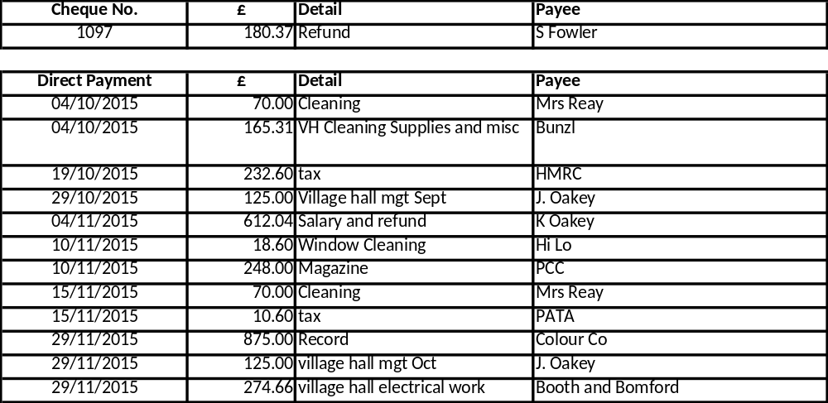

- Precept 2016/17
The detail, together with the latest 2015/16 monitoring position, was provided at Appendix B. All were in agreement that the precept should remain as per 2015/16 at £23,000. The Clerk reminded members that part of that was now funded via a grant from Cheltenham BC, with the balance being the precept. The Clerk would action the necessary letters to the Borough Council.

- Recreation & Culture
Cllr Worsley reported that the Parish Record went well and invoices had been issued for the adverts. He thanked all those involved in deliveries, and Cllr Bamford noted that it worked well getting them out earlier.

The Carol Service was also a success with around 200 people attending. It stopped raining just before the start and then the rain held off until it had finished. It was agreed that the Salvation Army and the Parish Church should receive payments in line with last year. The Clerk would action.

- Social & Community
It was noted that the Co-op in Warden Hill was moving across the road into the old Double Barrel pub. It was not known who would take over the old Co-op shop.

- Next Meeting
The next meeting will be on Tuesday 1st March, with a special meting to be confirmed during February to discuss the Stagecoach issue.

…………………………………………………….. 1 March 2016
Chairman

Appendix A



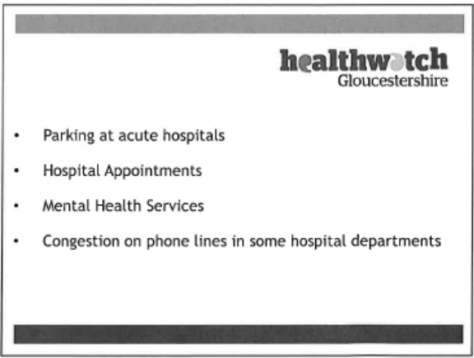
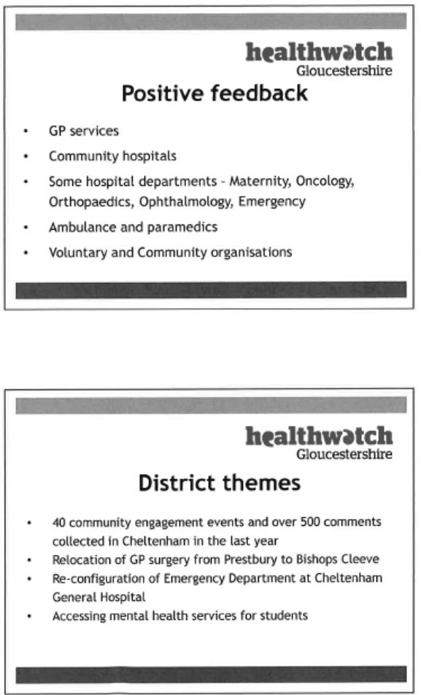
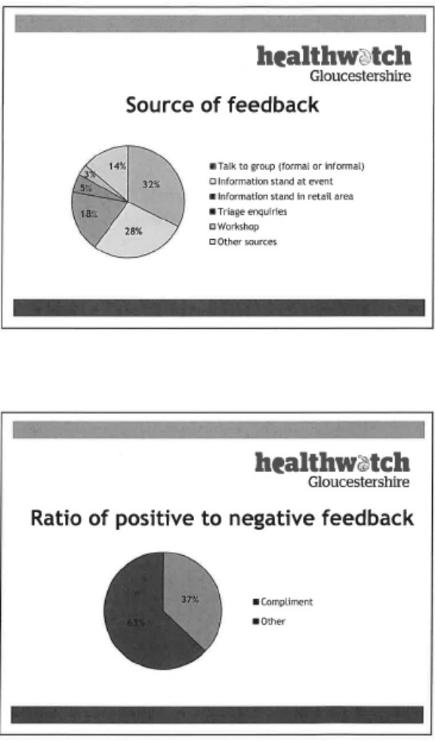
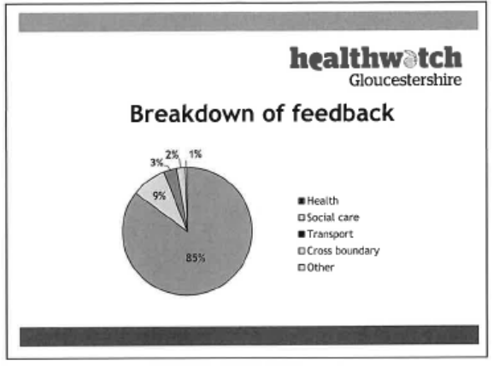




Appendix B
Precept Recommendation 2016/17 and Budget Monitoring 2015/16



